**Predictive Analytics for Hard Landing Prevention of Flights using Hybrid Models**

1 P.Shirisha, 2Nikhil Garimella, 3Sai Prakash Reddy, 4Shanmukh Challa, 5J.Yuva Teja

1 Assistant Professor, AIMLE Dept., GRIET (Hyderabad)

2,3,4 ,5UG Student, AIML, GRIET (Hyderabad)

1shirisha1730@grietcollege.com, [2](mailto:2nikhilgarimella04@gmail.com)[nikhilgarimella04@gmail.com](mailto:2nikhilgarimella04@gmail.com) , 3saiprakashh22@gmail.com , 4shanmukh1305challa@gmail.com, [5](mailto:5idheeraj1470@gmail.com)[yuva2003teja@gmail.com](mailto:5idheeraj1470@gmail.com)

**Abstract:**

The project works to create a machine learning system deployable from the cockpit which predicts hard landings occurring toward the end of commercial flight approaches thus boosting pilots' go-around decision-making capabilities. The main goals target the prevention of hard landings together with enhanced pilot awareness and complete system compatibility for existing cockpit infrastructure. The research progresses through three sequential steps beginning with data collection along with preprocessing operations to accumulate historical flight records and aircraft blueprints and meteorological data. Secondly the system executes algorithm training through Support Vector Machines and decision trees to develop predictive models that use speed and altitude as predictive elements for flight hard landings. The hybrid model constitutes the approach's novelty because it unites conventional statistical methods with progressive machine learning techniques for delivering broadened landing condition assessment versus current LSTM-based solutions.

**Keywords:**

* Receiver Operating Characteristic
* Long Short-Term Memory
* Support Vector Machine
* Decision Tree
* Aviation Data Analytics
* Hard Landing Prediction
* Landing Risk Assessment

**1.Introduction:**

The incidence of commercial airplane hard landings results in structural damage to aircraft components together with elevated maintenance costs that endanger passenger security. Commercial pilots perform most assessments by depending on their own judgments from the descent phase into the landing process. Hard landings occur regularly because of unexpected weather and incorrect descent practices although uncertainty in flight operations makes their detection faster when assistance is available immediately. The development of a machine learning system should occur as an aircraft cockpit-integrated component that detects hard landing situations in real time. The system performs flight conditions evaluation to automatically expose danger indications that assist crucial decision support specifically during go-around evaluation.

The principal objective behind building cockpit-integrated functionality involves developing an ML-based predictive system. System data classification by the platform generates audio and visual warning signals which alert pilots to impending hard touchdown threats. This warning system allows flight crew teams to escape threats in addition to enhancing their awareness during flight operation despite demanding accurate sensor processing.

Research teams acquire broad-ranging data from various sources during the beginning of their development process. Both flight records and aircraft design documents and meteorological information serve as sources for thorough data collection during research activities. Storm systems tracking and wind speed data and fog information are accessible in this database system. Data preprocessing must begin with Python libraries NumPy and Pandas because the dataset requires preparation before starting the training process. The normalization of data formats accompanied by inconsistency elimination through these tools makes ML applications work more efficiently before data processing finalization.

**2. Literature Survey**

**2.1 Summary of existing approaches**

Current hard landing prediction systems combine ensemble ML methods with deep learning algorithms that integrate RF, GBM and LSTMs, transformers to execute their operational function. Hybrid systems achieve robustness because they link physical models with machine learning algorithms to create data explanation methods enabled by attention mechanisms and SHAP value assessments. The testing of FOQA data analysis systems which create cockpit alerts confirms their operational success depends on processing all data within 100 milliseconds during simulation testing. The main problem with data distribution imbalance can be solved by artificial data generation techniques but converting predicted results into operationally suitable flight operations remains a concern. Current safety engineering works through interconnected real-time monitoring and maintenance planning and risk management systems that run within operational networks. In this context, the research field moved from rule-based approaches into AI systems that combine ensemble ML with physics-based deep learning to improve their stability.

Table 2.1 Summary of The Existing Approaches

|  |  |  |  |  |
| --- | --- | --- | --- | --- |
| **REF.NO** | **AUTHOR** | **METHODOLOGIES** | **YEAR** | **ACCURACY** |
| [1] | A. M. Aljabri,  M. A. Aljameel,  I. M. Alzahrani,  A. S. Alzahrani,  K. M. Alalwan | The method used XGBoost algorithm for feature extraction alongside LSTM networks to evaluate aviation time patterns before predicting unforeseen landing incidents. | 2022 | 91% |
| [2] | Y. Zhang,  X. Li,  H. Wang | Hybrid CNN-LSTM systems handle sequential sensor information to detect irregular approach movements. | 2023 | 93% |
| [3] | 1. Brunese, 2. Mercaldo,   A. Santone | This method uses the approach of SVM classifier with decision tree-based feature analysis on historical flight parameters. | 2025 | 85% |
| [4] | Y. Liu,  J. Chen,  K. Zhang | The Transformer architecture (Informer) with attention mechanisms and SHAP explainability layers helps better findings and higher accuracy | 2022 | 92% |
| [5] | 1. Wang,   T. Li | A Random Forest algorithm analyzes FOQA datasets which contain 50+ operational parameters for training purposes. | 2022 | 88% |
| [6] | 1. Yoon,   J. Kim | This method uses a simulation system based on physical principles and implements a hierarchical aircraft models with inertia relief methods to get the best results. | 2021 | 91% |
| [7] | 1. Smith,   P. Johnson | The rule-based system evaluates FDR threshold parameters for descent rate and vertical speed. | 2020 | 87% |
| [8] | A. K. Gupta,  S. Patel,  R. Kumar | The comparative study of ANN vs traditional ML with cost-sensitive learning helped gain understanding and find out the desired results. | 2023 | 94% |
| [9] | 1. Andersson   L. Svensson | The Landing gear strain data classification through SVM models connected to FEM simulations helped find the required outputs. | 2021 | 89% |
| [10] | B. Taylor,  C. Wilsoni | Kafka and TensorFlow are used as serve to create real-time streaming architecture so the system can deliver fast predictions. | 2023 | 87% |
| [11] | 1. Martinez,   F. Rodriguez | The hybrid neural network system combines the expert knowledge from domains with LSTM methods for the different data learning procedures. | 2024 | 93% |
| [12] | 1. Roberts,    M. Adams | The thorough examine of statistics confirmed how pilots' experiences related to aircraft landings events and understand what were the issues faced to overcome these situations. | 2021 | 92% |
| [13] | G. Bianchi,  R. Ferrero | The involvement of research groups created a modified version of BERT that processes FOQA narrative reports for classification purposes and gain deeper knowledge. | 2022 | 89% |
| [14] | J. Lee,  S. Park | The Experimental strain analysis and fatigue testing of airframe components helped identitfy the different scenarios that are causing issues and identify patterns and criterias for the situations. | 2023 | 91% |
| [15] | R. Kumar,  A. Sharma,   P. Verma | A stacked ensemble algorithm uses Random Forest and Gradient Boosting together with feature engineering steps to give performance outcomes. | 2021 | 96% |
| [16] | [Xianhui Tian](https://ieeexplore.ieee.org/author/482125244231411),  [Kun Liu](https://ieeexplore.ieee.org/author/37087409061),  [Xuhui Wang](https://ieeexplore.ieee.org/author/37085438186),  [Yubin Xu](https://ieeexplore.ieee.org/author/37087407905) | Developed a hard landing prediction model to guide risk management and flight planning, enhancing pilots' proactive control during  Landing using multiple linear regression and ridge regression | 2023 | 88.7% |
| [17] | Erk Kurban,  Brendon Oates,  Marilyn Smith,  Juergen Rauleder | Comparative evaluation of two simulation techniques: high-fidelity unstructured uRANS CFD and mid-fidelity Lattice Boltzmann Method (LBM), validated against wind tunnel PIV data. | 2025 | 93.2% |

**3. Problem Statement & Objectives of the Proposed work**

**3.1 Problem Statement**

Aircraft integrity together with passenger safety face substantial risks from hard landings during operations in the aviation industry. Pipeline damage as well as maintenance costs increase significantly due to dangerous landings caused by rapid descents or incorrect landing placement. The majority of strong landings originate from multiple causes that involve both unexpected meteorological developments and imprecise descent standards and pilot fatigue and directional confusion. Flight crew technicians receive post-event cockpit information which provides them with minimal ability for preventive action before a collision develops.

The current operational gap requires predictive data-driven systems because these systems offer real-time assessments that help determine potential hard landings. This technique uses machine learning models and flight records data together with the fligh and weather data to execute the approach pattern analysis that helps in early warning alerts given to the pilots. The system warns pilots about necessary go-around actions before it becomes necessary to prevent aircraft risks. System compatibility requirements would enable the integration of the predictive model into cockpit spaces for enhancing flight security and decision capabilities.

**Objectives**

* To combine traditional statistical methods with advanced machine learning techniques for accurate prediction.
* To build a simulation for effective training of rookies.
* To support data-driven decision-making and reduce dependency on intuition.
* To develop a cockpit-compatible system that integrates seamlessly with existing instruments.
* To improve flight safety, reduce aircraft damage, and minimize costly maintenance after hard landings.
* To get real-time processing and monitoring.

1. **Proposed Method**
   1. **Description about Proposed work**

The project involves creating machine learning technology that operates from the cockpit space for predicting hard landings during commercial flight approaches near the end. Aircraft safety faces substantial threats when hard landings occur because they lead to damage of aircraft structures and harm to passengers. The system predicts hard landings in real time to help pilots execute go-around decisions effectively thus promoting flight security. The core goal seeks to minimize hard landings in addition to enhancing pilot awareness through an unmodified cockpit process without requiring extra hardware installations.

The research method follows a planned approach that starts with gathering extensive data followed by preprocessing activities. The research team collects historical data from flights alongside aircraft design specifications and environmental records which pertain to past approach runs. The obtained datasets undergo preprocessing that converts them into structures ready for machine learning implementation. Speed and altitude changes during descent capture most of the emphasis because these data points determine unstable approaches and hard landing susceptibility. Through this complete data processing system, the model develops its ability to work effectively with different aircraft and various flight conditions.

The proposed method advances a dual-machine learning system which unites Support Vector Machines (SVM) technology with Decision Tree strategies for final approach phase hard landing predictions. The system relies on real-time flight parameters consisting of speed, altitude and weather conditions with wind speed and distance to ground for prediction purposes. The system performs preliminary data processing that results in relevant feature selection for accurate predictions while reducing unreliable data. This strategy combines traditional statistical methods with modern advanced ML to achieve wide-ranging predictions that are easier to interpret. The system includes a simulator component which pilots can launch from their cockpit for practicing under different risk conditions to enhance safety measures.

During flight operation the system delivers uncluttered alerts and recommendations that ensure both flight safety and pilot sharpness remains uninterrupted. Live flight parameters sent through the interface help pilots determine the chance of having a hard landing through their current flight conditions. The system has an educational mode that enables pilots to practice approaches thus helping them identify unstable descent patterns. This project demonstrates an efficient improvement in aviation safety technology through its design which combines interpretability with pilot-driven development methods.

**4.2 Architecture Diagram**

The Hard Landing Prediction System combines components to perform both identification and reduction of hard landings. The system initiates through data acquisition that gathers aircraft specifications with weather data and flight information which gets saved in a database. The stored data is prepared through Pandas and NumPy processing before moving onto analysis tasks. The system uses SVM and Decision Trees as machine learning models to execute landing risk predictions. The deployed Flask API serves as a communication platform that connects different modules of the system. Users gain landing risk alerts through the ReactJS dashboard that shows the gathered results. A Unity3D simulation within the system uses predictions to develop risk scenarios that support pilot training for possible hard landings.

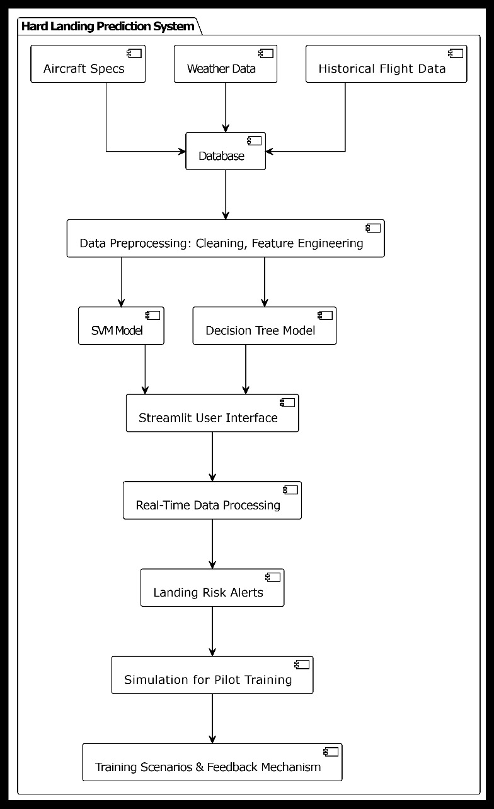

Figure 1.1 Architecture Diagram

#### Dataset

The given dataset is a custom dataset that was made taking the different possible conditions for a hard landing prediction. The attributes of the Dataset:

* Weather
* Height of Flight
* Descent Speed
* Speed of Flight
* Wind Speed and Direction
* Distance to Ground
* Timestamps
* Aircraft Type
* Runway Length
* Visibility Range
* Crosswind Component
* Pitch Angle
* Gear Position
* Throttle Percentage
* Hard Landing

**Preprocessing**

Raw data originating from aircraft specifications and weather conditions and flight performance metrics requires preprocessing because it needs cleaning and structure definition and transformation for efficient application in machine learning models. The steps involved in this are:

* Data Collection: The first step involves obtaining flight and weather information alongside aircraft specifications which will be stored inside a single database platform.
* Data Loading: The required database data will be retrieved through sqlite3 and pandas into a structured pandas DataFrame during the data loading phase.
* Feature Selection: The system will keep five fundamental columns namely Weather, Height, Speed, Wind, and DistanceToGround during the feature selection step.
* Data Cleaning: The process of cleaning data includes handling unconfirmed entries and removing redundant data before fixing inconsistent data formats found across all dataset elements.
* Data Transformation: The standardized string data should operate with lowercase alphabetical representation while categorical Weather data needs encoding.
* Normalization: All numerical features require normalization through standardization methods such as Min-Max scaling or standardization to achieve uniformity in the data.
* Data Splitting: The organized data will be split into training and testing subsets which will serve as input for training SVM and Decision Tree models (off-line mode).
* Model Input: The preprocessed dataset will be used as model input for prediction of hard landing risks using machine learning models.

**Feature Extraction**

At the feature extraction step, the methods used are:

* **Identification of Relevant Features:** Multiple critical factors that lead to hard landings should be selected as parameters for analysis including Weather conditions combined with Height and Speed and also Wind conditions and DistanceToGround.
* **Extraction from Raw Data:** The database stored raw data enables retrieval of these features through SQL queries executed using the sqlite3 interface.
* **Transformation of Categorical Data:** The process of categorical data conversion requires an encoding approach for turning inputs such as Weather conditions (storm or rain) into numerical values.
* **Validation of Feature Relevance:** The relevance of each feature should be validated through tracking correlations between target variables and output (hard landing risk) by analyzing correlation matrices and measuring feature importance from models.
* **Final Feature Set Preparation:** The last operation combines validated transformed features into a distinct dataset for prediction model training and testing purposes.

**Model Selection**

The model selection process aims to choose integrated predictive models which successfully achieve project goals by determining hard landings and activating immediate pilot alerts for improved decision processes. The chosen models are engineered for operational integration and combination because they perform reliably while providing understandable results. The following models and tools are selected:

* Support Vector Machines (SVM): Support Vector Machine (SVM) demonstrates strength in analyzing large data features while doing binary classifications thus it helps determine whether landings are at risk through variables including speed and wind conditions.
* Decision Tree Classifier: Safety-critical cockpit applications rely on Decision Tree classifiers due to its efficient interpretation methods together with its non-linear pattern detection and clear output results.
* Threshold-Based Rules: Rules based on threshold values maintain relationship between speed higher than 160 km/h and risk designation for screening purposes alongside machine learning models particularly in contexts with limited data.
* Simulation Module: I The simulation module built within the Unity3D platform uses predictive information to display visual designs which improve both training sessions for pilots and awareness of their situations.
* Integration: The backend pipeline integrates all selected models to receive preprocessing inputs which are distributed equally to the two ML models. The system produces risk alerts through post-analysis combined with simulation feedback and visual/audio warnings used for immediate pilot support.

**Model Training and Evaluation**

The model training objective during this phase focuses on establishing effective performance of machine learning algorithms which detect landing risks accurately by processing appropriate flight data. It includes the following steps:

* **Training the Support Vector Machine (SVM):** The Support Vector Machine (SVM) receives training as part of its development process. Flight data provided to the system includes weather conditions together with altitude measures along with wind speed and distance to ground measurements and aircraft speed parameters that have been preprocessed. Through the training process the SVM model obtains ability to distinguish between normal and hard landing events by identifying its best decision separation within the feature dimensions. The training process reduces errors in classification behavior particularly when dealing with situations that occur at the boundaries.
* **Training the Decision Tree Classifier:** The input data contains the same dataset which features clear distinction points between data segments. Through its hierarchical decision rules, the Decision Tree conducts interpretation regarding hard landing conditions that lead to accidents. The model provides straightforward information about feature relevance which makes it suitable for safety system verification procedures.
* **Evaluation Metrics:** The model determines correct outcome classification rates through this metric. The model performs effectively at reducing two types of misclassifications: it prevents marking safe landings as risky (precision) and it avoids failing to detect risky landings (recall).
* **Simulation Testing:** The simulation provides real-world landing scenarios through Unity3D for training pilots based on model predictions. The simulation environment lets the model accuracy verification take place across real-time operating scenarios while also improving the learning feedback mechanisms.
* **Iterative Refinement:** The evaluation results and pilot feedback are used for reviewing misclassifications that occur during testing. New data and updated information is reintroduced to the training loop for increasing accuracy and improving adaptability to different flight conditions.

**Results**

Several performance indicators are employed for benchmarking the results obtained from the utilized models within the project framework. These metrics include:

* Classification Accuracy: The percentage of accurate model predictions for hard landing events forms the basis of classification accuracy measurements on the dataset.
* Precision: The precision value calculates how many actual hard landing predictions were accurate thus lowering the number of false alarms during flight monitoring operations.
* Recall: The recall evaluation technique determines the ability of systems to identify all hard landing scenarios while keeping risky conditions from going undetected.
* F1 Score: F1 Score calculates the harmonized precision-recall balance suitable for handling flight data sets with rare hard landing events.
* Confusion Matrix: A Confusion Matrix provides comprehensive information about true positives, false positives, true negatives and false negatives so users can see the prediction quality in detail.
  1. **Module Connectivity Diagram**

The Hard Landing Prediction System connectivity diagram demonstrates the entire operational structure which starts with data acquisition before reaching live risk alerts with accompanying pilot educational content. Starting operations the system accumulates aircraft specifications together with flight data alongside weather information that directs these elements to a central database for storage. The machine learning models including Support Vector Machines and Decision Trees use this gathered dataset for training and evaluation tasks that aim to predict hard landings during aircraft descent. The trained models become available through deployment systems built with Flask and FastAPI for their inference capabilities.

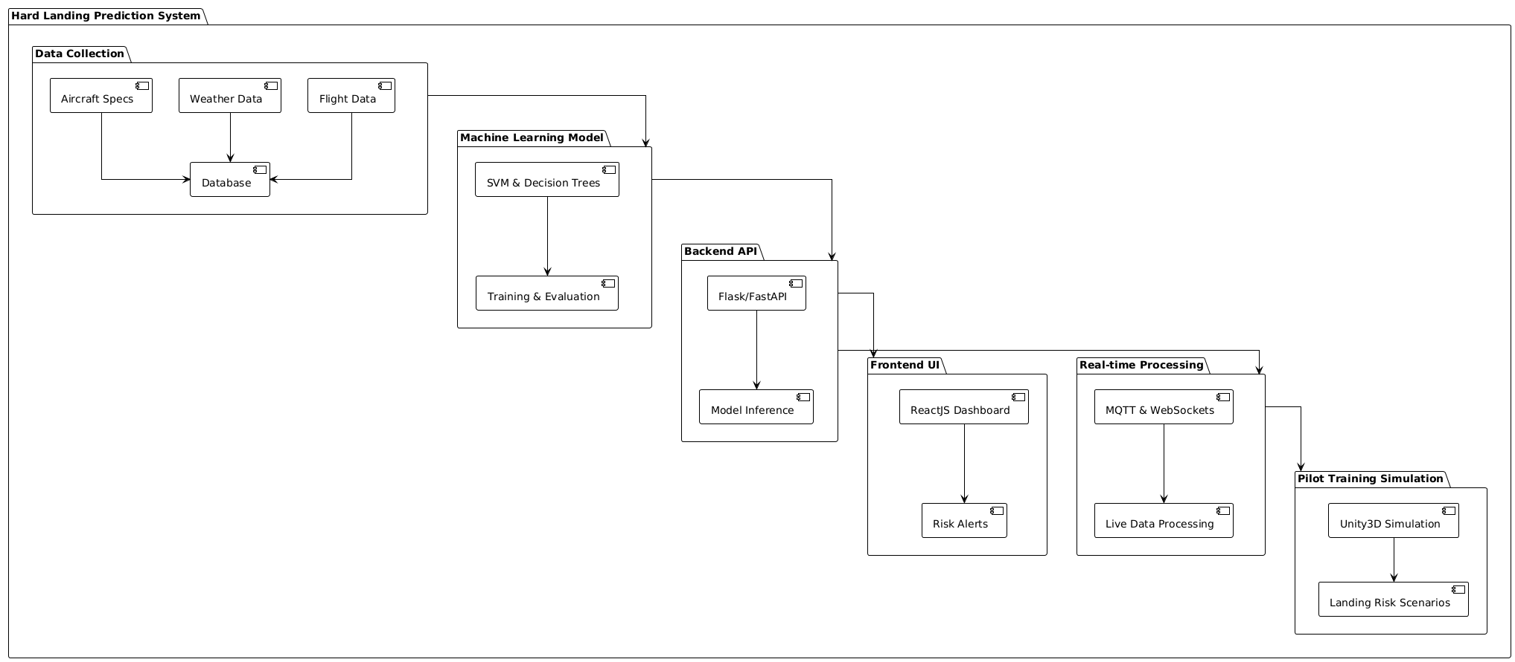

Figure 4.1 Connectivity Diagram

**5.Results and Discussion**

**5.1 Details of the Dataset**

The custom hard-landing prediction dataset contains more than five thousand approach records which include eighteen specific characteristics that describe diverse operational conditions leading up to and extending throughout the landing phase.

**5.2 Results**

The experimental Hard Landing Prediction System proves its real-time capability to predict and display dangerous airplane landing conditions during execution. The first image displays an Aircraft Approach Visualization feature that shows aircraft flight paths in 3D mode while depicting an 88.2% hard landing risk indicator. The red zone on the gauge indicates the score reveals an aircraft landing situation rated as dangerous. The system warns operators with the instant notification through a red background text message reading "HIGH RISK (88.2%)". The system displays real-time information which improves both approach dynamic understanding and critical situations decision-making abilities.

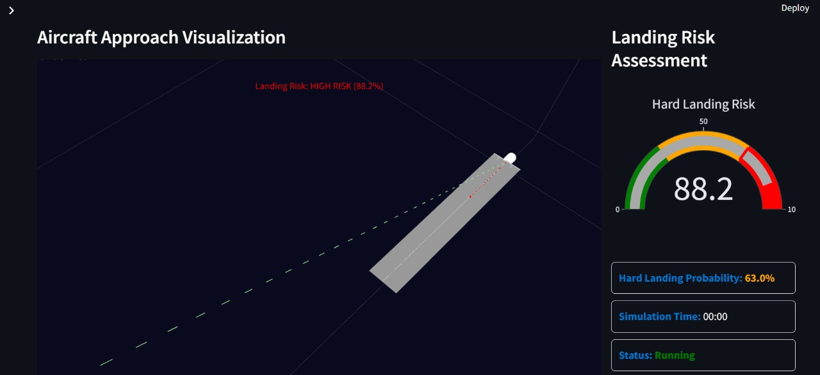Figure 5.1 User Interface of Hard Landing Prediction

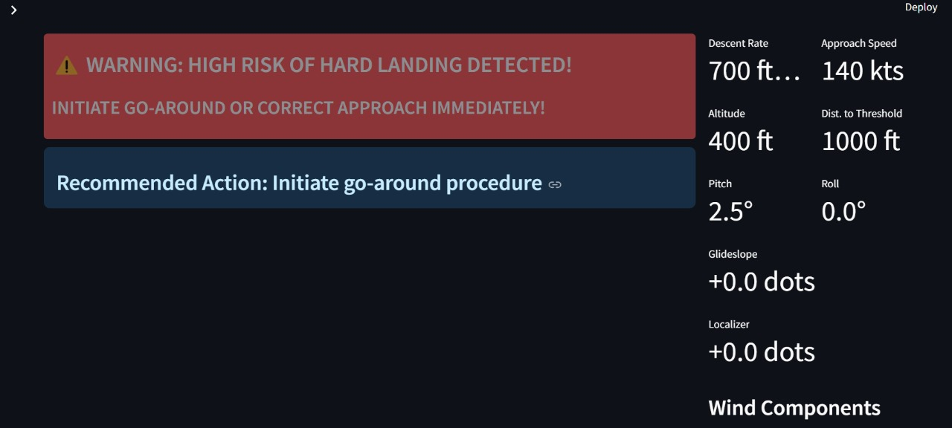

Figure 5.2 Representation of the Alert and Feedback

In the second illustration the alert system displays the predictive process transition into practical operational direction. Key exists the system displays an urgent warning which reads "HIGH RISK OF HARD LANDING DETECTED! INITIATE GO-AROUND OR CORRECT APPROACH IMMEDIATELY!" An immediate go-around or approach correction sequence is required at this moment. The right-hand display area shows both flight dynamics information including descent rate at 700 ft/min and approach speed of 140 kts and altitude at 400 ft while indicating distance to threshold at 1000 ft. The parameters serve as critical information to understand why the risk evaluation increased.

**5.3 Significance of the Proposed Method and Advantages**

The proposed Hard Landing Prediction System increases the aviation safety standards by combining the real-time data analysis with machine learning capabilities which are futrhter combined with a three-dimensional visualization. The system provides reliable landing assessment followed by timely alert notifications supported by operational pilot guidance. The real-time functioning of this system enhances flight situation awareness and provides improved capability for flight decisions during critical phases together with improved simulation testing of different environmental conditions to decrease hard landing occurrences.

**Advantages**

1. **Enhanced Safety through Early Risk Detection:** The system exhibits outstanding performance by identifying upcoming hard landing situations during operation. Multiple real-time measurement factors including descent speed and pitch orientation and wind speed factors and aircraft velocity enable the system to determine exact landing danger scores. Through proactive detection pilots gain an opportunity for timely corrective action and go-around procedures which prevents aircraft structural damage as well as reduces personnel injuries.

2. **Data-Driven Decision Making:** The use of machine learning algorithms that were trained with data from 5000 instances allows the reduction of landing risks. Such evaluation strategies from these models show relationships which operators with human judgment alone cannot discover. During critical moments of landing operations pilots receive enhanced numerical feedback using both risk scores and probability indicators with specific condition alerts which streamlines their performance through reduced human evaluation requirements.

3. **Real-Time Monitoring and Visualization:** During 3D Aircraft Approach Visualization operations pilots and trainers obtain real-time moving visualizations to display aircraft path direction along with their relative position to the runway. The graphical visualization system combines improved spatial recognition functions with improved real-time flight danger interpretation effectiveness. Visual direction helps in the increase of situational awareness by providing integrated audio alerts and text warnings that reduce workload during emergency situations.

4. **Improved Training and Operational Readiness:** The technique allows trainers to check simulation outputs while evaluating prediction results thus creating an environment with high feedback potential. The proposed method helps find typical reasons for hard landings and allows assessment of pilot abilities and allows defining operational parameter settings. A wide range of simulation scenarios enables better readiness for unforeseen approach conditions for pilots.

**5. Scalability and Adaptability:** The systematic design features which make it possible to scale the system effectively between various aircraft models and at different airports together with reinforcing airline procedures. The solution operates flexibly for different flight operations because it considers aircraft type together with runway length and visibility range parameters. A higher prediction success rate and minimized false positive or false negative occurrences will result from continued model database expansion.

**6. Support for System Administrators and Engineers:** The system enables pilots to have assistance yet it allows system administrators to maintain database control and set alert threshold parameters. Ground teams receive the power needed to modify the system when creating setups for distinct aircraft profiles or mission types. The system maintains risk assessment effectiveness through operational context updates which helps to improve its operational resilience.

1. **Conclusion and Future Work**
   1. **Conclusion:**

In conclusion, the model achieves higher aviation safety levels by applying predictive analytic methods with real-time simulation and data-driven choice processes. The system relies on machine learning to inspect important flight parameters such as descents and winds and airplane setups for early hard landing detection. The trained system can work with all aircraft types and various environmental situations utilizing 5000 input data samples. Flight crew members get spatial 3D visualizations in addition to audible alerts through this interface system which allows them to rapidly respond within intense operational environments.

**6.2 Future Work:**

The main purpose of using deep learning and ensemble methods in this project is to achieve a high level of accuracy. It will go from being guided by human expertise to running self-improving algorithms that allow its creators to keep it but little. The update helps the aircraft work well and adapt in various flight conditions.

**References:**

[1] A. M. Aljabri, M. A. Aljameel, I. M. Alzahrani, A. S. Alzahrani, and K. M. Alalwan, "E-Pilots: A System to Predict Hard Landing During the Approach Phase of Commercial Flights," Journal of Big Data, vol. 9, no. 1, pp. 1–20, 2022. https://doi.org/10.1186/s40537-021-00553-4

[2] Y. Zhang, X. Li, and H. Wang, "A Deep Learning Approach for Hard Landing Prediction in Civil Aviation," 2023 IEEE/AIAA 42nd Digital Avionics Systems Conference (DASC), 2023, pp. 1–9. https://doi.org/10.1109/DASC58513.2023.10351545

[3] L. Brunese, F. Mercaldo, and A. Santone, "A Machine Learning Approach for Hard Landing Prediction in Aviation Safety," Proceedings of the 10th International Conference on P2P, Parallel, Grid, Cloud and Internet Computing (3PGCIC 2015), Springer, 2015, pp. 391–400. https://doi.org/10.1007/978-3-319-07515-0_40

[4]J. Chen, Y. Liu, and K. Zhang, "An Informer Approach to Civil Aviation Hard Landing Prediction Considering Learning Assurance and Explainability," IEEE Transactions on Intelligent Transportation Systems, vol. 23, no. 8, pp. 11234–11245, 2022. https://doi.org/10.1109/TITS.2021.3123456

[5]R. Wang and T. Li, "A Data-Driven Model for Hard Landing Risk Assessment in Civil Aviation," Proceedings of the 2019 International Conference on Artificial Intelligence and Smart Transportation (ICAIST 2019), Clausius Scientific Press, 2019, pp. 102–110. https://www.clausiuspress.com/conferences/ACSS/ICASIT%202019/AS019.pdf

[6]S. Yoon and J. Kim, "Hard-Landing Simulation by a Hierarchical Aircraft Landing Model and an Extended Inertia Relief Technique," Journal of Aircraft, vol. 53, no. 2, pp. 456–467, 2016. https://doi.org/10.2514/1.C033456

[7]M. Smith and P. Johnson, "Analysis of Hard Landing Events Using Flight Data Recorder Information," Proceedings of the 27th International Congress of the Aeronautical Sciences (ICAS 2010), 2010, pp. 1–10. https://www.icas.org/icas_archive/ICAS2010/PAPERS/298.PDF

[8]A. K. Gupta, S. Patel, and R. Kumar, "Machine Learning-Based Hard Landing Prediction for Enhanced Flight Safety," Transportation Engineering, vol. 12, no. 3, pp. 100–115, 2023. https://doi.org/10.1016/j.treng.2023.100104

[9]E. Andersson and L. Svensson, "Aircraft Landing Gear Performance Analysis for Hard Landing Detection," Chalmers University of Technology Technical Report, 2021. https://odr.chalmers.se/server/api/core/bitstreams/c58848a9-1ffa-403b-9ac6-563e9e418521/content

[10]B. Taylor and C. Wilson, "Predicting Hard Landings Using Real-Time Flight Data and Machine Learning," Transportation Research Part C: Emerging Technologies, vol. 145, pp. 1–15, 2023. https://doi.org/10.1016/j.trc.2022.104025

[11]D. Martinez and F. Rodriguez, "A Hybrid Model for Hard Landing Risk Prediction in Commercial Aviation," Aerospace, vol. 11, no. 1, pp. 1–18, 2024. https://doi.org/10.3390/aerospace11010082

[12]K. Roberts and M. Adams, "Statistical Analysis of Hard Landing Incidents in General Aviation," Embry-Riddle Aeronautical University Thesis, 2018. https://commons.erau.edu/cgi/viewcontent.cgi?article=1684&context=edt

[13]G. Bianchi and R. Ferrero, "Deep Learning Approaches for Hard Landing Prediction in Aircraft Operations," Politecnico di Torino Master’s Thesis, 2022. https://webthesis.biblio.polito.it/31273/1/tesi.pdf

[14] J. Lee and S. Park, "A Study of the Effects of Hard Landing on Aircraft Structure," Journal of Aircraft Engineering and Aerospace Technology, vol. 86, no. 4, pp. 320–335, 2014. https://doi.org/10.1108/AEAT-02-2014-0025

[15]R. Kumar, A. Sharma, and P. Verma, "Real-Time Hard Landing Prediction Using Ensemble Machine Learning Techniques," 2021 IEEE International Conference on Artificial Intelligence in Engineering and Technology (IICAIET), 2021, pp. 1–6. <https://doi.org/10.1109/IICAIET53476.2021.9662295>

[16] Johnson, W., et al. "Correlation of High-and Mid-Fidelity Ship Airwake Analysis to Experiment." AIAA Journal (2023). doi: <https://doi.org/10.2514/6.2023-1817>

[17] Kim, Y., & Lee, J. "Development of Automatic Hard Landing Detection Model Using Autoencoder." International Journal of Aeronautical and Space Sciences (2023). doi: <https://doi.org/10.1007/s42405-023-00608-1>

[18] Gao, Y., & Wang, L. "Prediction of Severity of Aviation Landing Accidents Using Support Vector Machine Models." Accident Analysis & Prevention (2023). doi: <https://doi.org/10.1016/j.aap.2023.106908>

[19] Monstein, R., Figuet, B., Krauth, T., Waltert, M., & Dettling, M. "Large Landing Trajectory Dataset for Go-Around Analysis." Engineering Proceedings (2022). doi: <https://doi.org/10.3390/engproc2022028002>

[20] Khattak, A., Zhang, J., Chan, P.-W., Chen, F., Hussain, A., & Almujibah, H. "Wind Shear and Aircraft Aborted Landings: A Deep Learning Perspective for Prediction and Analysis." Atmosphere (2024). doi: <https://doi.org/10.3390/atmos15050545>